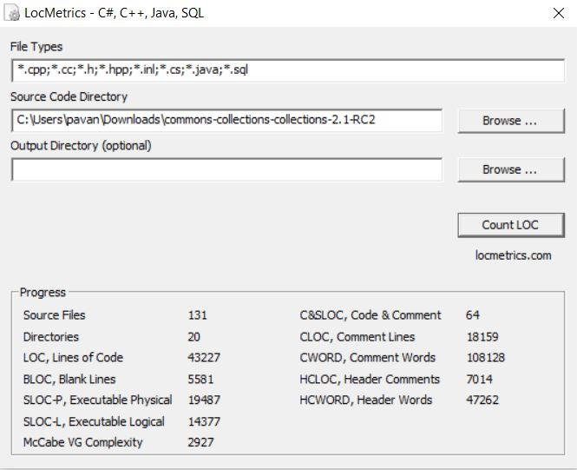

Apache Commons Collections 2.1 : Defect density = 18/19487 = 0.000923

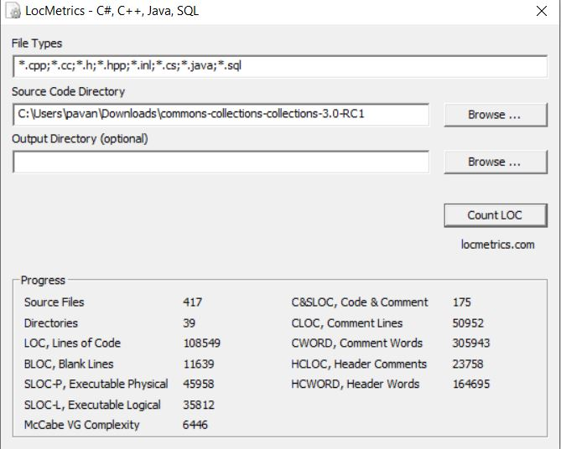

Collections 3.0 Defect density = 15/45958 = 0.000326

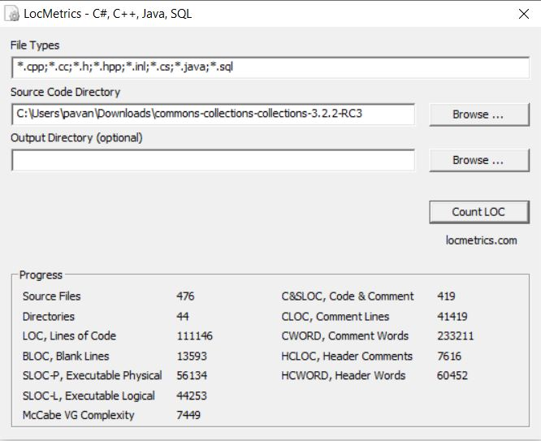

Collections 3.2 defect density = 55/56134 = 0.000979

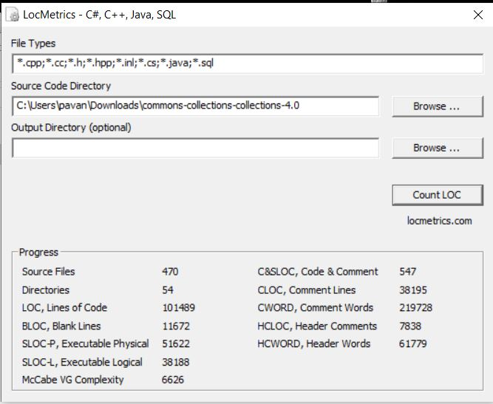

Collections 4.0 defect density = 34/51622 = 0.000658

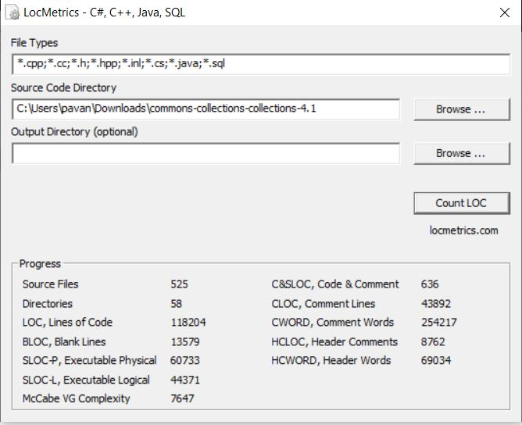

Collections 4.1 defect density = 16/60733 = 0.000263

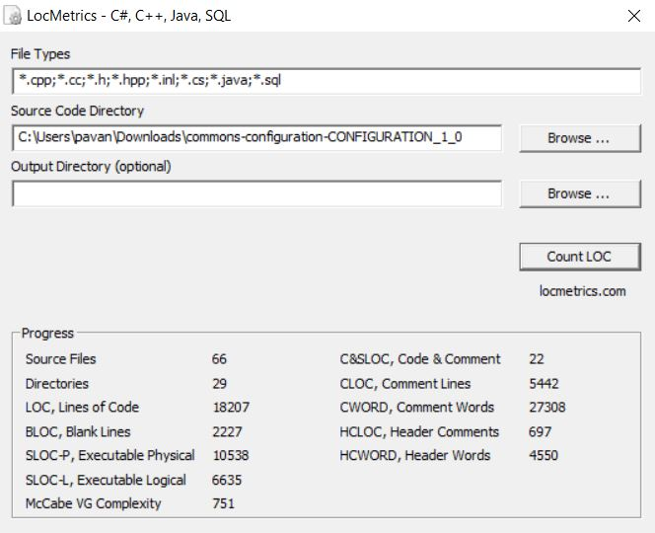

Configurations 1.0 defect density = 7/60733 = 0.000115

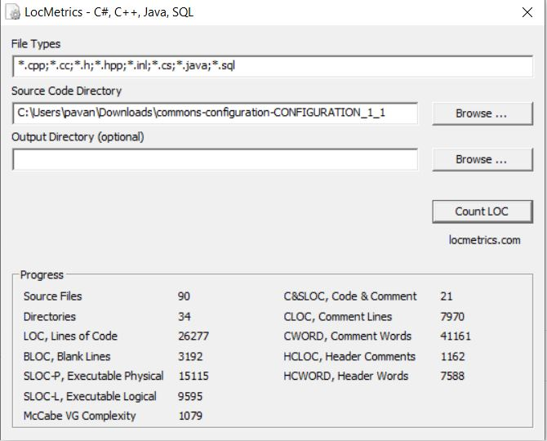

Configurations 1.1 defect density = 55/15115 = 0.00363

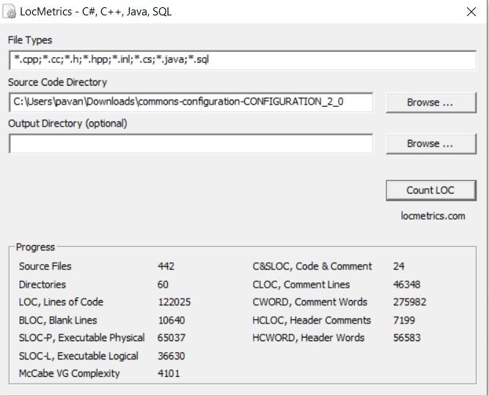

Configurations 2.0 defect density = 11/65037 = 0.000169

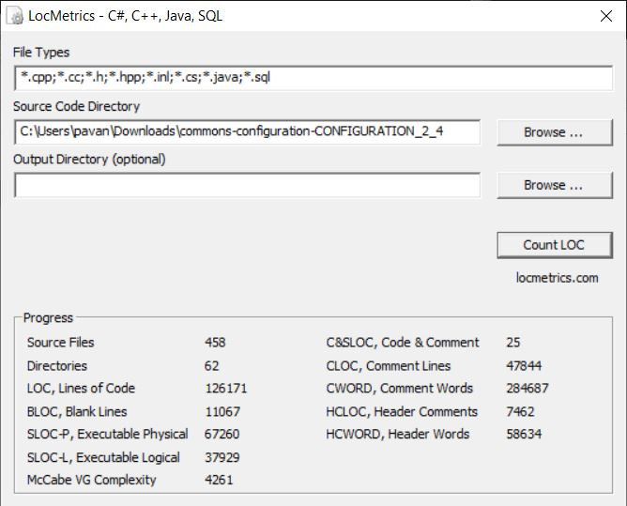

Configurations 2.4 defect density = 2/67260 = 0.0000297

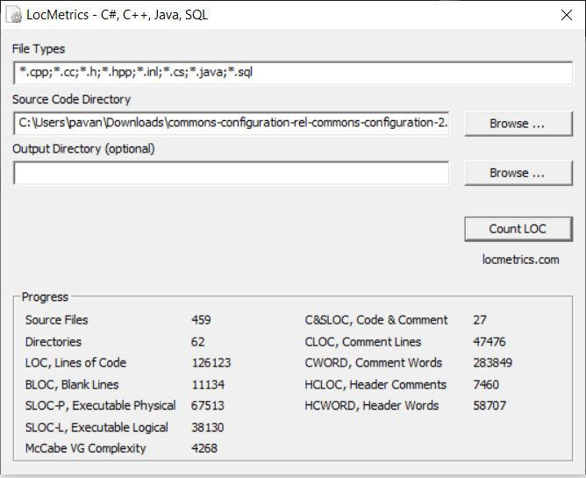

Configurations 2.6 defect density = 4/67513 = 0.0000592

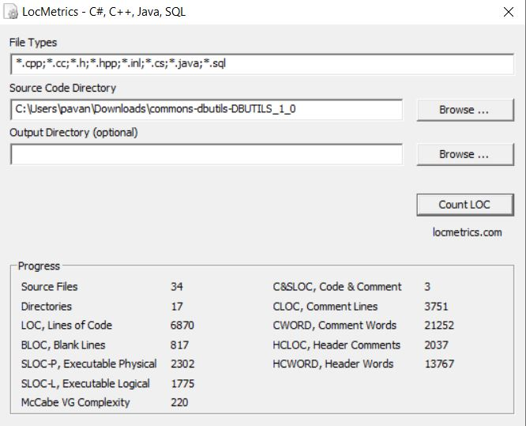

Dbutils 1.0 defect density = 4/2302 = 0.001737

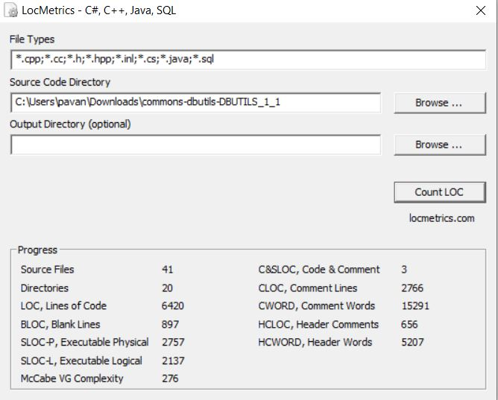

Dbutils 1.1 defect density = 8/2757 = 0.002901

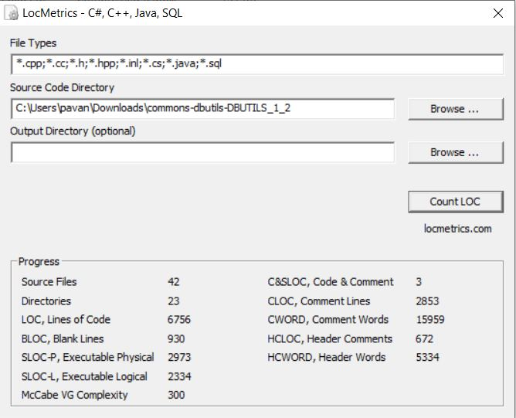

Dbutils 1.2 defect density = 4/2973 = 0.001345

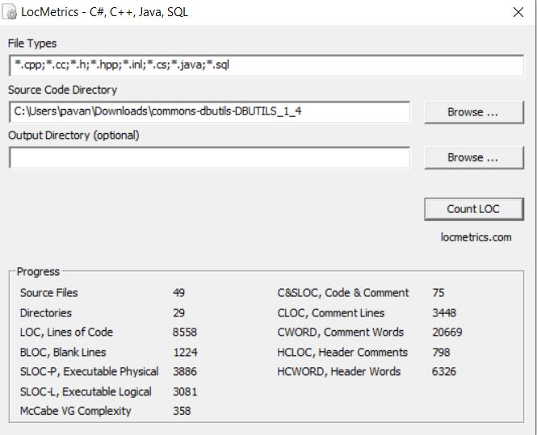

Dbutils 1.4 defect density = 2/3886 = 0.000514

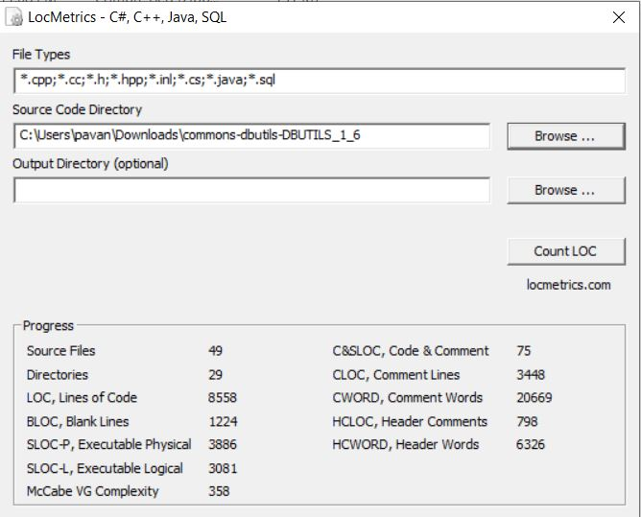

Dbutils 1.6 defect density = 4/3886 = 0.001029